Hewlett Packard Enterprise Channel Services Network Partner
Reseller Guide to the Hewlett Packard Enterprise Support Services Tool
September 2021

The purpose of this guide is to help you better understand the Hewlett Packard Enterprise fixed support services (previously known as Fixed Care Packs) ordering, assignment and registration tool within the Hewlett Packard Enterprise Channel Services Network.

Table of Contents
Table of Contents 2
Hewlett Packard Enterprise Fixed Support Services Tool Overview 3
Minimum System Requirements 4
Starting the System 5
3.1 Launching HP Enterprise CSN 5
3.2 HP Enterprise CSN Login Procedure 6
3.3 Login Error Messages 8
HP Enterprise Fixed Support Services Tool Home Page 9
4.1 Using the Home Page and Navigation Bar 9
Fixed Support Services Registration 10
5.1 Registering Fixed Support Services 10
Bulk Registration 23
6.1 Registering Using Bulk Upload 23
Update Registration 27
7.1 Updating Registrations 27
Partner Inquiries 31
8.1 Get Registration Report in Excel Format 33
8.2 Get Orders Detail Report in Excel Format 35
8.3 Get the Sales Orders Placed Within a Date Range and/or by the P.O. Number 37
8.4 Perform an Inquiry on the Sales Order Number 40
8.5 Find the Registration Information Based on Serial Number 42
8.6 Get the Registration Information Based on Fixed Support Services Serial Number 44
8.7 Get Registrations Expiring in a date range 46

Hewlett Packard Enterprise Fixed Support Services Tool Overview
Section 1

In this increasingly complex world, partners need an easy way to find and select the appropriate services to compliment the sale of hardware. Hewlett Packard Enterprise Services is driving the way forward with eSelling. The advantages of eSelling are important to Hewlett Packard Enterprise, Hewlett Packard Enterprise Services, our partners, and customers. eSelling promotes:

- Ease of doing business
- Ease of selling
- Ease of buying
- Speed of doing business
- Worldwide access to products and service
- Constant availability to information about products and services

Partners discover even more positive attributes as they search out and select services online, including:
- Representation — Up-front representation of services included with all applicable products
- Accuracy — Accurate service information
- Consistency — Consistent location to find services when selecting products on the Web

The HP Enterprise fixed support services tool benefits reseller by enhancing the hassle-free support services purchase experience, where everything is taken care of at the time of purchase. There is no need to wait for a packaged service to be delivered; it is available instantly. What is more, the electronic HP Enterprise fixed support services tool has a positive environmental impact; eliminating the use of paper goods, storage, and movement of physical stock.

Minimum System Requirements
Section 2

Hewlett Packard Enterprise Channel Services Network has been tested and supports Internet Explorer 8.0 and higher on Microsoft Windows platforms as well as other browsers like; Firefox, Chrome and Safari.
Please contact http://www8.hp.com/us/en/contact-hp/contact.html if you have any additional questions regarding browser requirements or compatibility issues while using HP Enterprise CSN.

 | Notes  You do not have to specify any particular security settings under Internet Options. HP Enterprise CSN does not make use of any Active-X controls, so the application works fine even at high security settings.  HP Enterprise recommends that you delete all Temporary Internet Files regularly and with each new release of HP Enterprise CSN.

Starting the System
Section 3

3.1 Launching HP Enterprise CSN

The HP Enterprise fixed support services tool is located within the HP Enterprise CSN system and is accessible via the HPE Ready Partner Portal.

Log in to the HPE Ready Partner Portal using your credentials.
https://partner.hpe.com/web/public/login

Notes
To access the system you must be a member of the HP Enterprise CSN virtual community.

If your company is currently a Hewlett Packard Enterprise Authorized Reseller or Service Provider, but IS NOT a member of the HP Enterprise CSN community, go to http://csn.hpe.com/ to apply for membership.
If your company is currently a Hewlett Packard Enterprise Authorized Reseller or Service Provider and IS a member of the HP Enterprise CSN community, please contact your company’s HP Enterprise CSN Administrator to add an additional user or location.

3.2 HP Enterprise CSN Login Procedure

Step 1 Enter a valid “user id”.
Step 2 Enter a valid “password”.
Step 3 Click the “SIGN IN” button.
HPE Partner Ready Portal Login Screen
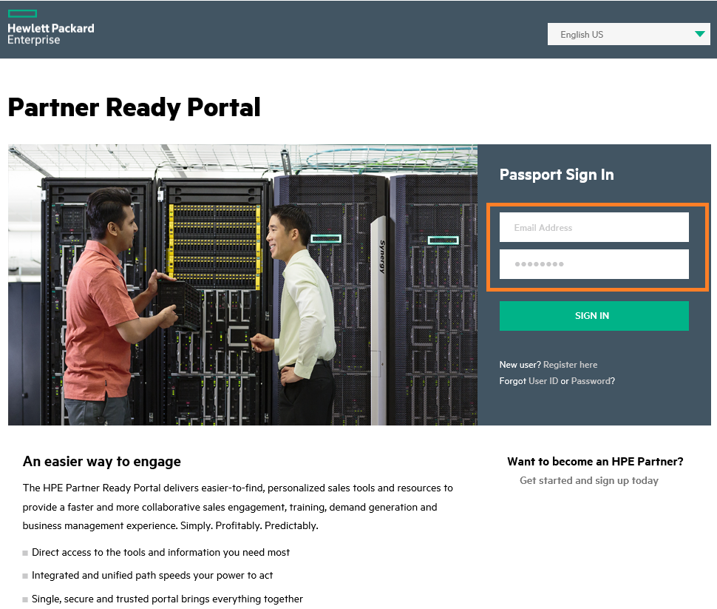

By entering a user id and password and following the login procedure, you are agreeing to the HP Enterprise Terms of Use, also located here.

Step 4 Hover over “My Workspace” and click “Channel Services Network” under the “Orders” section.

Hewlett Packard Enterprise Partner Ready Portal Screen
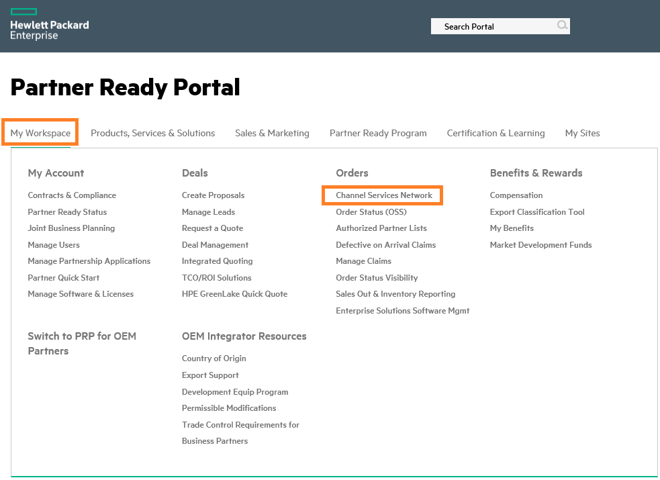

Step 5 Click “Go” in the HPE Channel Services Network page.

At this point, the HPE CSN page opens.

Hewlett Packard Enterprise Channel Services Network Login Screen
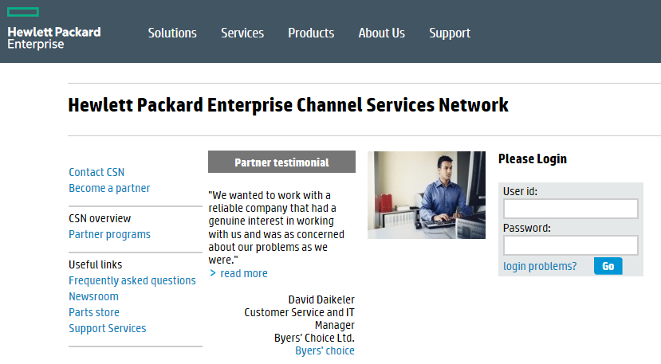

By entering a user id and password and following the login procedure, you are agreeing to the conditions mentioned below.

PLEASE REVIEW THE TERMS AND CONDITIONS SET FORTH BELOW PRIOR TO GAINING ACCESS TO THE HEWLETT PACKARD ENTERPRISE NETWORK.

Only those persons authorized by Hewlett Packard Enterprise may use this network and only for legitimate business purposes. If you are not an authorized user, please disconnect now.

Hewlett Packard Enterprise has the capability and reserves the right to audit ALL computers and systems, including the file contents of such systems and computers, which are connected to the Hewlett Packard Enterprise network. This message serves as notification of this fact to you. By completing the login process, you are consenting to such audits. If you object, discontinue the login process now. No further warning or notice will be given.

Additionally, Hewlett Packard Enterprise reserves the right to inspect, without further notice, all electronic communications, data, and information stored or transmitted on the Hewlett Packard Enterprise network. Hewlett Packard Enterprise also reserves the right to add necessary files to and modify the configuration of any connected computer or system to ensure both the security and integrity of the Hewlett Packard Enterprise network. Misuse of the Hewlett Packard Enterprise network is prohibited. Misuse includes:

- Making unauthorized copies of software licensed to Hewlett Packard Enterprise, or acquiring such;
- Placing or using unauthorized software on any computer or system on the Hewlett Packard Enterprise network;
- Transmitting or forwarding proprietary data for other than legitimate Hewlett Packard Enterprise business; and
- Attempting or gaining access to systems or productivity units to which you have not been granted access.

Hewlett Packard Enterprise will pursue legal remedies against any person who misappropriates or misuses the Hewlett Packard Enterprise network to the full extent of the law. Any violation of this policy will result in appropriate sanctions, up to and including termination of business relationship. By completing the login process, you are consenting to the above terms of usage for the Hewlett Packard Enterprise network. If you object, discontinue the login process now. No further warning or notice will be given.

3.3 Login Error Messages

If you do not enter a valid HP Enterprise Partner Ready Portal user id or password, the following error message displays:
ERROR: “Please enter your password. If you do not remember your sign-in information, click on the Password link below.”

At this point, make sure that you are typing the correct user id and password.

If you are certain that you are typing the correct information and still cannot login, click the “Forgot User ID or Password?” option. If you do not have an HPE Partner Ready Portal account, click the “New user? Register here” option to obtain one.

Notes
Please keep in mind that the password is case sensitive.

On occasion, a pop-up alert message may appear on the screen at login.

If you own multiple CSN accounts, when you log in to CSN you may have a drop-down to select which account you want to use. To change the account for another one, click on “Change Profile” at the top right of the screen.

HP Enterprise Fixed Support Services Tool Home Page
Section 4

4.1 Using the Home Page and Navigation Bar

The first step to understanding and using the HP Enterprise fixed support services tool, is logging in.
Step 1 Login to HP Enterprise CSN.
Step 2 From the HP Enterprise CSN console page, the menu page appears.
HP Enterprise CSN Console Page – Reseller Menu View
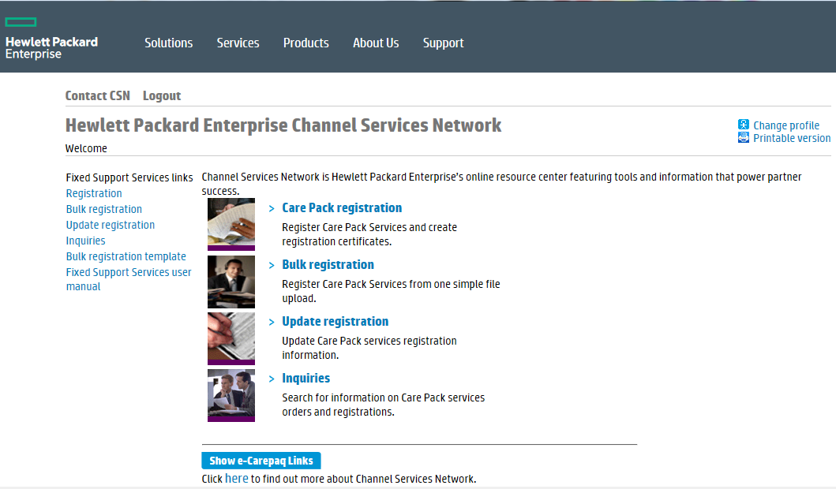
Menu Options for Resellers
Standard Navigation Bar on All HP Enterprise Fixed Support Services Tool Pages

Fixed Support Services Registration
Section 5

Congratulations on your recent fixed support services purchase. The next step is to register the fixed support services, so your customer can begin enjoying all the benefits.
With the recent changes to the ordering processes, many fixed support services will be automatically registered based on the information provided on the order, so you or your customer will not have to register manually.
However in the few cases where this is required, follow the instructions in this section.
Bold Data Entry Fields

Throughout the HP Enterprise fixed support services tool, you will notice that some data entry fields are bold, while others are not. Bold fields are required for processing. Please complete all bold fields as applicable.

5.1 Registering Fixed Support Services

Notes
For the orders to be visible in your account, the orders need to be assigned to your company’s CSN Reseller ID. This is usually done by the distributor as they process new orders.

With the recent HPE changes and the deployment of HPE NEXT, an auto-assignment process has been enabled that will automatically attempt to assign the orders to your CSN Reseller account using the Reseller address and email information provided on the order.

Step 1 From the HP Enterprise fixed support services tool home page, choose the “registration” option from the menu page.
Note
At this point, the Registration page appears.

Fixed Support Services Registration Screen
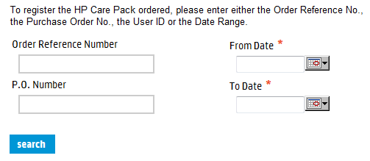
Step 2 To register the fixed support services ordered, please enter at least one of the following:
- Order Reference Number
Note
The order reference number is the reference number provided at order creation and should be provided by the distributor. (Example: EME0045678)

You can also use the P.O. number query function if you do not have the order reference number.

- P.O. Number
- Date Range (From Date – To Date)

Step 3 Click the “search” button.
At this point, a list of fixed support services orders appears.

HPE Support Services Registration – Order List
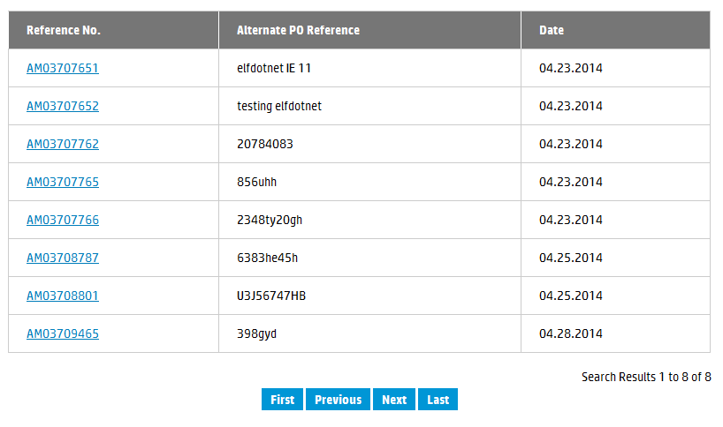

Step 4 Locate the appropriate order and click the hyper-linked reference number.
Note
At this point, the Order Information and Registration Information tabs appear. The Order Information tab is the default.

Order Information Tab – Registration
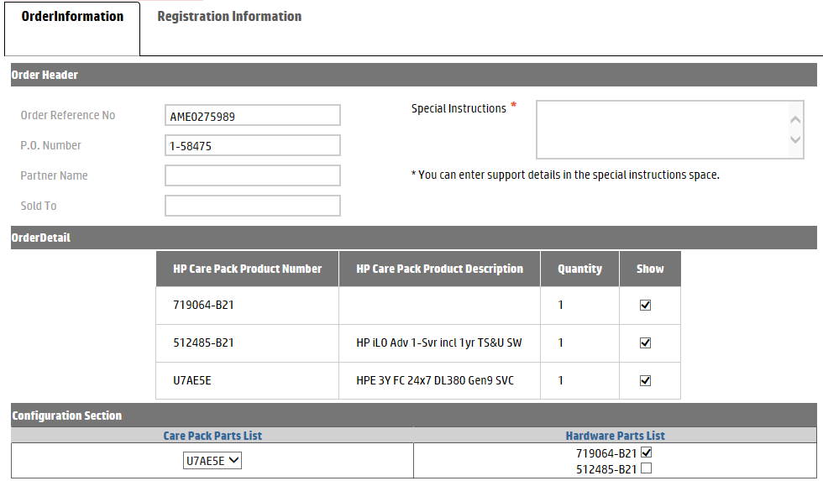
Step 5 Review the Order Header and Order Detail information carefully, to ensure you are registering the correct fixed support services.
Notes
The “Show” check box under the Order Detail section of the page only appears if the order contains hardware and services. Check the “Show” box if you want the line items visible for configuring the hardware to the service. The configure feature is not available if the order does not contain hardware.

The configure feature allows you to link fixed support services to a hardware product, if applicable. The configure feature is not available if the order does not contain hardware.

Step 6 Enter any applicable support details in the Special Instructions section.
Important Note!
When services and hardware are sold together on the same order, HP Enterprise CSN allows you to configure the hardware to the appropriate service. Steps 7a and 7b are not applicable when the order does not contain hardware.

Step 7a Under the Configuration Section, select the appropriate fixed support services from the Care Pack Parts List drop down menu.
Note
The Configure Section of the screen will not appear if the order does not contain hardware.

Step 7b Check the appropriate parts under the Hardware Parts List to link with the fixed support services selected in Step 7a.
Step 8 Click the Registration Information tab.
At this point, Registration Information page appear.

Registration Information Tab – Customer and Registration Details
(displayed using two images)

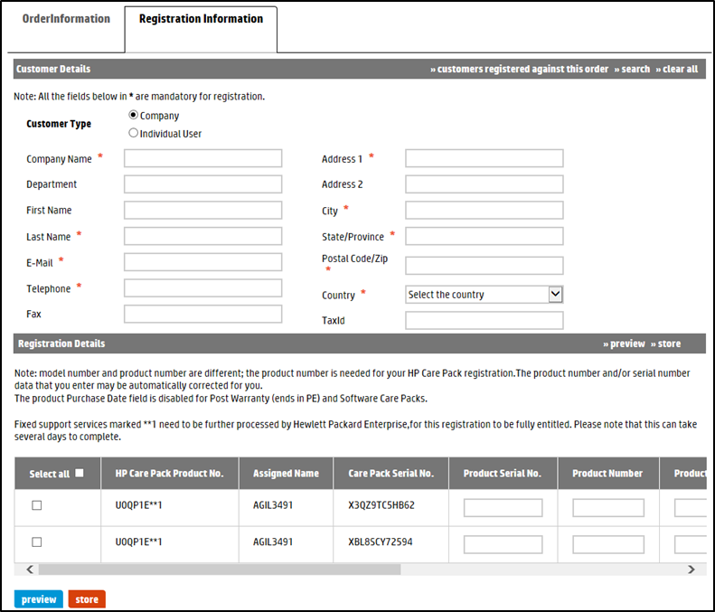
Registration Information Tab – Product Registration Details (continued)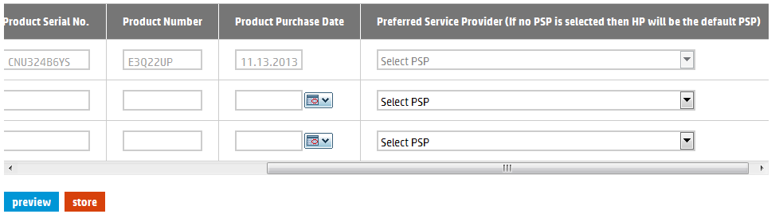
Notice the scroll bar that allows you to view all the fields for each product.
Step 9 Enter the Customer Details.

Notes
Customer Details represent the company name, address and contact information of the customer which will interact with Hewlett Packard Enterprise to receive support. This is where the equipment is located.

The “>>search” option allows you to automatically populate the Customer Information fields by entering search criteria in one or more of the required fields. If a match for the information is not found, the system will alert you.

Initially, the customer list holds no data, but each time you enter new Customer Information the system saves the data for future use.

Step 10 Under Registration Details, check the box of the fixed support services you want to register. Alternatively, you can check the box directly under “Select all” to register all fixed support services listed.
Notes
Fixed support services that include some proactive deliverables (like Proactive Care support) or software support, need to be further processed by Hewlett Packard Enterprise, for this registration to be fully entitled. These fixed support services are identified with **1 beside the fixed support services part number.

Click the “store” button to save the Customer Details and Registration Details, in order to complete the registration later.

Step 11 Enter the Product Serial Number and Product Number for each fixed support services ordered.
Notes
Notice the + sign to the right of the Care Pack Services Serial No. Based on hardware information availability, + sign will display the product serial number and product number as hyperlinks. Click the appropriate link to automatically populate the Product Serial Number and Product Number text boxes.

The Configure Section and associated + sign are not available if the order does not contain hardware.

A hardware product number is not necessary when the unit has a 12-digit serial number.

Step 12 If required; enter the Product Purchase Date. This represents the date the customer purchased the hardware that is to be supported by the fixed support services.
Notes
This field is optional. If you do not enter product purchase date, this will default to the product purchase date recorded in Hewlett Packard Enterprise systems.

The product purchase date cannot be more than 90 days from the Hewlett Packard Enterprise recorded product purchase date. If the date entered is more than 90 days from the Hewlett Packard Enterprise recorded product purchase date, the fixed support services will be registered and the system will use the Hewlett Packard Enterprise recorded date to set the fixed support services period. A warning message to this effect will appear on the screen.

This Product Purchase Date field will be available for In-warranty fixed support services. It will not be available for software only or post-warranty fixed support services.

Step 13 Select your company as the Preferred Service Provider (PSP) for each fixed support services ordered.
Note
This field is optional. If you do not choose a PSP, the default provider is Hewlett Packard Enterprise. Also, the ability to choose a PSP is not an option for all users or fixed support services. Notice that this field is not accessible and grayed out if the option is not available to you.

Order Information Screen Selection Fields
Field | Type | Definition
Customer Details
>>search | List button | The “>>search” option allows you to automatically populate the Customer Information fields by entering search criteria in one or more of the required fields. If a match for the information is not found, the system will alert you.  Initially, the customer list holds no data, but each time you enter new Customer Information the system saves the data for future use.
>>clear all | Clear button | Click this button to clear all data entered under Customer Information.
Customer Type | Button | Select the company or individual for customer type.  Note: Bold fields must be completed to execute the order. The required fields may be different depending on the customer type you choose.
Company Name | Text field | Enter the company name.  Note: Required field for customer type: company.
Department | Text field | Enter the appropriate department.
First Name | Text field | Enter the first name of the contact person.  Note: Required field for both customer types: company and individual.
Last Name | Text field | Enter the last name of the contact person.  Note: Required field for both customer types: company and individual.
Email | Text field | Enter the email address for the contact person.  Note: Required field for customer type: company.
Telephone | Text field | Enter the telephone number for the contact person.  Note: Required field for both customer types: company and individual.
Fax | Text field | Enter the fax number for the contact person.
Address 1 | Text field | Enter the address.
Address 2 | Text field | Enter the address.
City | Text field | Enter the city.
State/province | Text field | Enter the state or province.
Postal Code/zip | Text field | Enter the postal or zip code.
Country | Drop down menu | Select the appropriate country.
TaxId | Text field | Enter the customer tax identification.  Note: Only required for Russia.
Order Information Screen Selection Fields (continued)
Registration Details
preview | Button | Once all registration information is entered, click this button to view the registration information.
store | List button | Click this button to save the Customer Details and Registration Details, in order to complete the registration at a later time.
Select all | Check box | Check the box next to the fixed support services you want to register.  Note: To select all fixed support services, check the box directly under “Select all”.
HP Care Pack Service Product No. | Text field | This field automatically populates.
Care Pack Serial No. | Text field | This field automatically populates.
Product Serial No. | Text field | Enter the product serial number.
Product Number | Text field | Enter the product number.  Note: A hardware product number is not necessary when the unit has a 12-digit serial number.
Product Purchase Date | Date selection | Enter or select the Product Purchase Date.  Note: If you do not enter a date, the default is the Hewlett Packard Enterprise recorded product purchase date.
Preferred Service Provider | Drop down menu | Select a Preferred Service Provider for each fixed support services ordered.  Note: If you do not choose a PSP, the default is Hewlett Packard Enterprise. This field is not accessible and grayed out if the option is not available to you.

Step 14 Click the “preview” button to view the registration information.
At this point, the Preview Registration page appears.

Preview Registration Screen
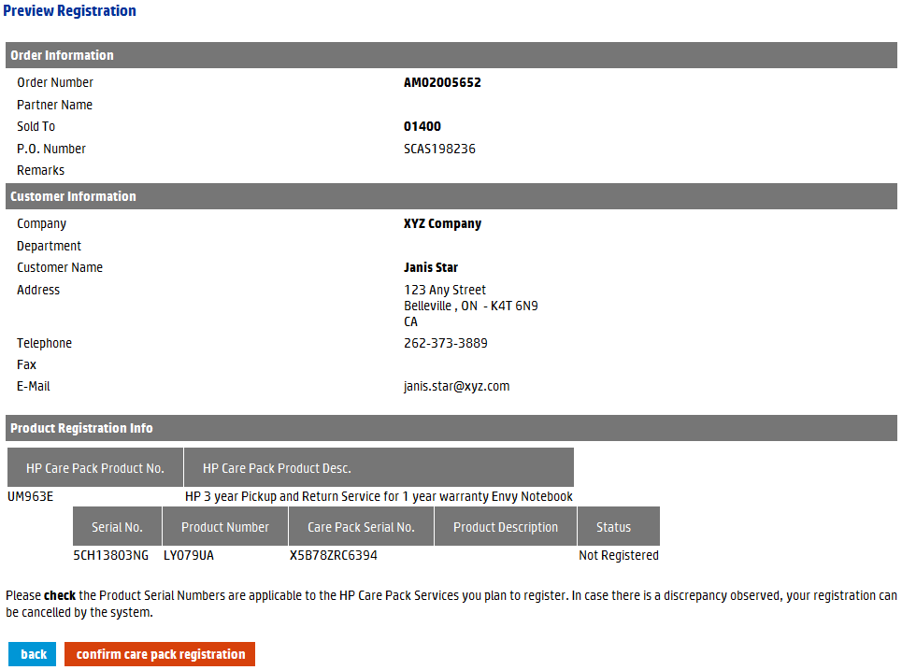
Notice that status is “Not Registered” at the preview step.

Step 15 Review the registration information carefully. If all of the information is accurate, click the “confirm care pack registration” button to complete the registration.
At this point, the message “Care Pack(s) Registered” appears at the top of the page.

Important Note!
Fixed support services that include some proactive deliverables (like Proactive Care support) or software support need to be further processed by Hewlett Packard Enterprise, for this registration to be fully entitled. Please note that this can take several days to complete.

Note
To change Customer Details or Registration Details, click the “back” button.

HPE Support Services Registration Screen
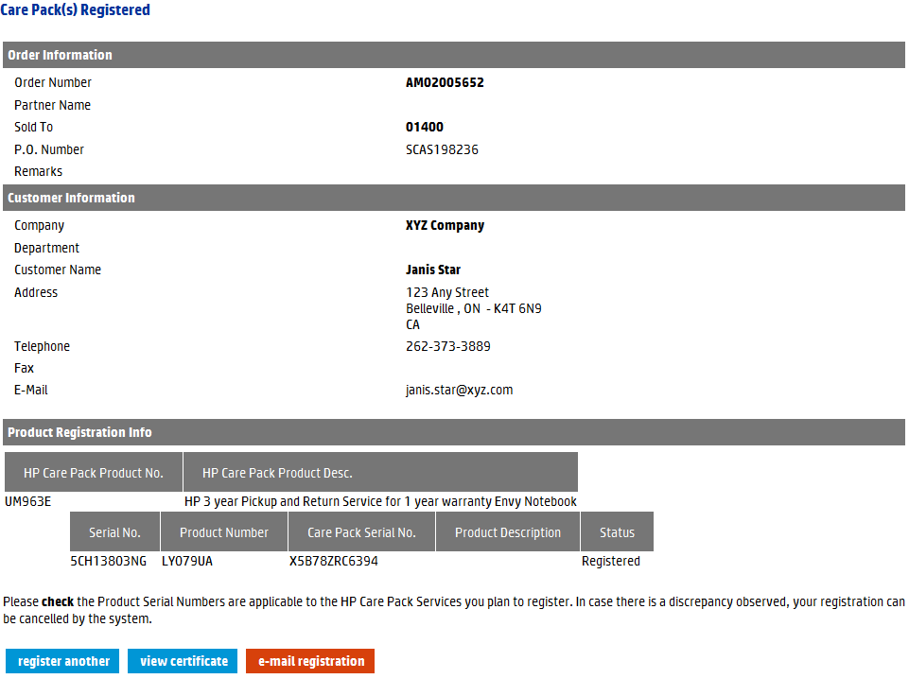
Notice that status is “Registered” at the registered step.

Step 16 To register other fixed support services, click the “register another” button. To forward an email with a link to print the certificate, click the “e-mail registration” button. To print the fixed support services registration certificate, click the “view certificate” button.
At this point, printing options for the fixed support services registration certificate appear.
Printing Options for Fixed Support Services Registration Certificate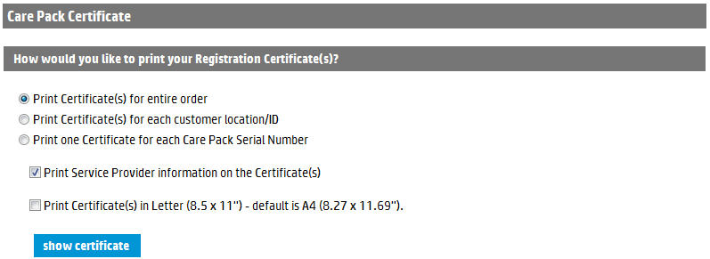

Notes
The Print Service Provider Information on the Certificate(s) option only applies if you chose a Preferred Service Provider at the time of registration.

The assignment of a Preferred Service Provider is not an option available to all users. This option must be enabled in the user’s profile. For more information, please contact your company’s Hewlett Packard Enterprise CSN administrator.

Step 17 Choose the preferred printing options.

Step 18 Click the “show certificate” button.

At this point, the fixed support services registration certificate appears.

HP Enterprise Fixed Support Services Registration Certificate

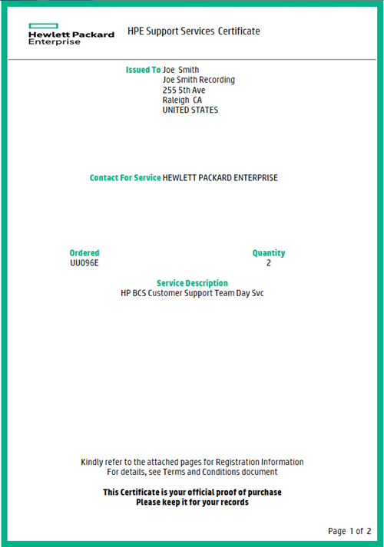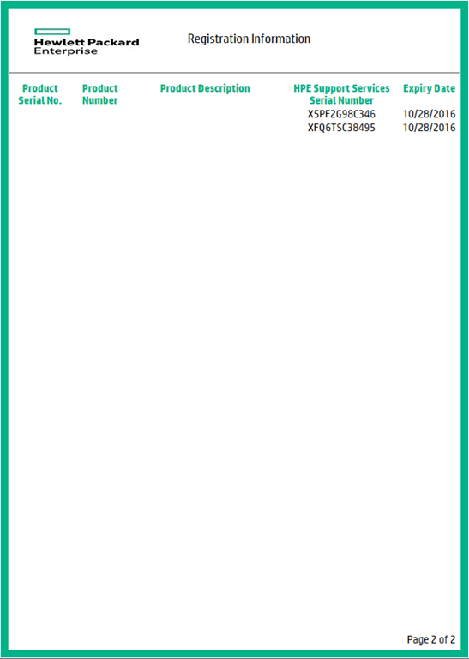

Notes
Each certificate includes information about the customer, the hardware product, the service, and the Preferred Service Provider, if selected.

To print the certificate, use your browser print option.

Bulk Registration
Section 6

6.1 Registering Using Bulk Upload

This functionality allows you to register several fixed support services at once, saving you valuable time and resources. This form is for registering fixed support services that have already been ordered, but not yet registered. It is especially helpful if you need to register large volumes of fixed support services.
Bold Data Entry Fields
Throughout the HP Enterprise fixed support services tool, you will notice that some data entry fields are bold, while others are not. Bold fields are required for processing. Please complete all bold fields as applicable.
Bulk Registration Template Guidelines
After you upload the completed template, you will receive an email confirming the bulk upload with details regarding the status. The file will state, by line item, if any line items were not successfully processed and why. In this case, correct any items and upload only those corrected line items for reprocessing. DO NOT UPLOAD THE ENTIRE FILE AGAIN!
Step 1 From the HP Enterprise fixed support services tool home page, choose the “bulk registration template” option from the left navigation bar and complete, at minimum, the required information fields.
Step 2 Enter, at least, the required information fields.
Notes
Bulk templates are universal for all regions. However, some fields might be mandatory in one region, but not in another. See the “How to Use This Template” tab within the template for more information.

An example of the Bulk Registration template is on the next page.

Bulk Registration Template (displayed using two images)
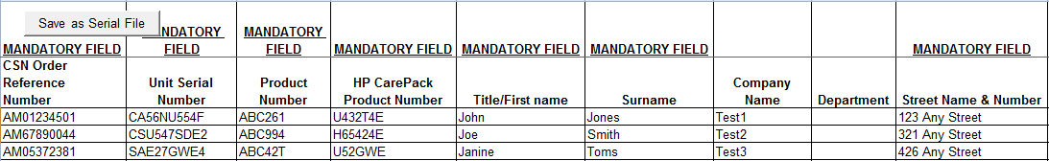

Bulk Registration Template (continued)
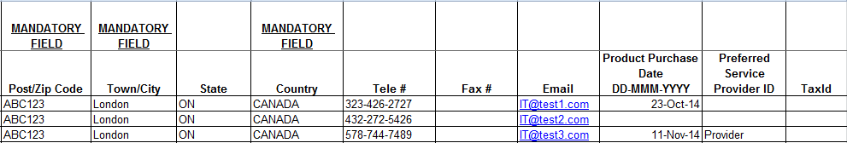

Important Notes!
You must use the “Save as Serial File” button embedded within the bulk template to save this file.

Opening two templates at the same time using Internet Explorer will cause a page error. When you open a template or report, it is highly recommended that you save it to your hard drive.

Step 3 Enter the Order Reference number.
Notes
The order reference number is the reference number provided at the end of an on-line order. (Example: EME0000123).

If you are unsure of your Order Reference Number, use the inquiries functionality to pull up the order by Date Range and/or P.O. Number and make a note of the associated Order Reference Number.

Step 4 If required; enter the Product Purchase Date. This represents the date the customer purchased the hardware that is to be supported by the fixed support services.
Note
This field is optional. If you do not enter product purchase date, this will default to the product purchase date recorded in Hewlett Packard Enterprise systems.

The product purchase date cannot be more than 90 days from the Hewlett Packard Enterprise recorded product purchase date. If the date entered is more than 90 days from the Hewlett Packard Enterprise recorded product purchase date, the fixed support services will be registered and the system will use the Hewlett Packard Enterprise recorded date to set the fixed support services period. A warning message to this effect will appear on the screen.

This Product Purchase Date field will be available for In-warranty fixed support services. It will not be available for software only or post-warranty fixed support services.

Step 5 If appropriate, enter a Preferred Service Provider (PSP).
Note
If you add your company’s PSP ID to some fixed support services, your company will be recognized as the service provide for all these fixed support services.

This field is optional. If you do not enter a PSP ID, the default provider is Hewlett Packard Enterprise.

The ability to choose a PSP is not an option for all users or fixed support services. This field will be disregarded if the option is not available.

Step 6 Use the “Save as Serial File” button, which is embedded in the Excel template, to save the file.
Step 7 Return to the Bulk Registration page of HP Enterprise CSN.
Step 8 Enter the file name of the Bulk Registration template completed earlier.
Step 9 Choose the “Bulk registration” option from the left navigation bar.
At this point, the Bulk Registration page appears.
Bulk Registration – File Upload Screen

Step 10 Click the “Browse…” button to retrieve the bulk ordering file saved earlier.
Step 11 Click the “upload file” button.
At this point, a Bulk Registration Confirmation message displays.
Bulk Registration Confirmation
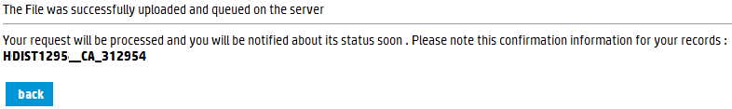

Step 12 Record the confirmation information for your records.
Important
You will receive an email confirming the bulk upload with details regarding status. The file will state, by line item, if any line items were not successfully processed and why. In this case, correct any items and upload only those corrected line items for reprocessing. DO NOT UPLOAD THE ENTIRE FILE AGAIN!

Important Note!
Fixed support services that include some proactive deliverables (like Proactive Care support) or software support need to be further processed by Hewlett Packard Enterprise, for this registration to be fully entitled. Please note that this can take several days to complete.

Update Registration
Section 7

This functionality allows you to update the customer information for any registered fixed support services. Should the customer move locations, or even move the registered hardware to a different location, it is critical that you update the customer information so they receive the proper service.

7.1 Updating Registrations

Step 1 From the HP Enterprise fixed support services tool home page, choose the “Update registration” option from the left navigation bar.
At this point, the Registration search page appears. Different search fields appear, depending on the search option you choose.
Update Registration Screen – Search by Serial Number (with Product Number)
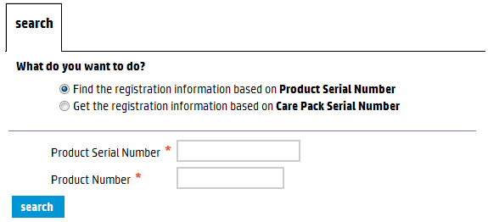
Update Registration Screen – Search by Care Pack Serial Number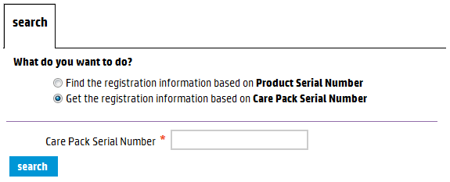

Note
To update the registration, you must first search for the proper fixed support services. You can search by hardware serial number (with product number) or by the fixed support services serial number. Different data entry search fields appear, depending on the search option you choose.

Step 2 To search for the proper fixed support services registration information, enter the serial number (with product number) or the fixed support services serial number.
Step 3 Click the “search” button.
At this point, the Customer Detail, Registration Detail, and the Order Detail for the fixed support services appear. You cannot update or modify the information in the Registration Detail or Order Detail sections.
Update Registration – Customer Detail Screen
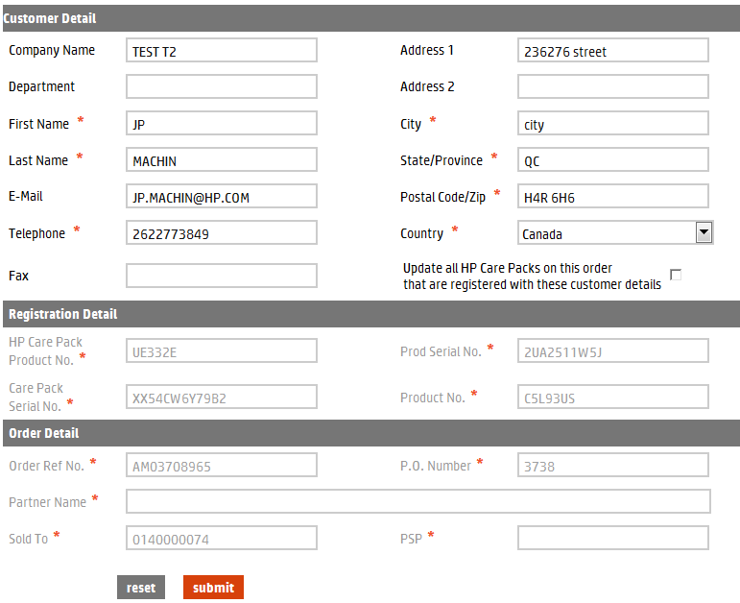

Note
Information about hardware cannot be modified at the user level. For example, if fixed support services are registered to a unit serial number that turns out to be DOA (Dead on Arrival), the registration information must be updated to reflect the serial number of the replacement unit.
In this instance, contact your Regional HP Enterprise fixed support services contact person or support line.

Step 4 Update the Customer Detail as needed, and then click the “submit” button. Click the “reset” button to erase any changes made and to restore the original customer information.
Once you submit the changes, the message “Registration Updated” appears above the Customer Details section.

Note
The reset function cannot be used after the submit function.

Partner Inquiries
Section 8

This function allows you to query several different reports for fixed support services. Report options include:
- Get Registration Report in excel format.
- Get Orders Detail Report in excel format.
- Get the sales orders placed within a Date Range and/or by the P.O. Number.
- Perform an inquiry on the Sales Order Number.
- Find the registration information based on Serial Number.
- Get the registration information based on Care Pack Serial Number.
- Find Registrations Expiring in a date range report.

Notes
Any inquiry that requires a date range (From Date – To Date) is limited to a maximum 45 days in range.

It does not matter the date chosen for the query start (From Date), but the range cannot extend more than 45 days from that date.

The end date (To Date) cannot extend past today’s date.

The “Get Registration Expiring in a date range report” is limited to a 90 days date range that can be any time in the past or the future. This report will return the results to the email address indicated in the Email ID field.

Step 1 From the HP Enterprise fixed support services tool home page, choose the “inquiries” option from the left navigation bar.
At this point, the Inquiries page appears.
Partner Inquiries Screen
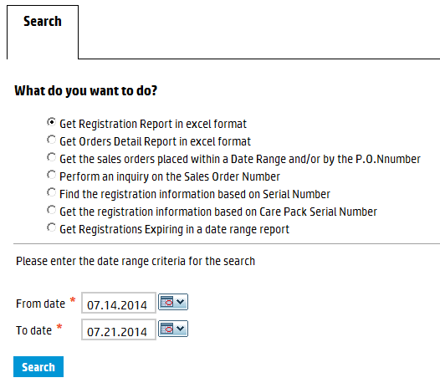
Step 2 Choose the preferred query option and proceed to Step 3 of the appropriate section, depending on the query option chosen.
Notes
To get Registration Report in excel format, proceed to section 8.1.
To get Orders Detail Report in excel format, proceed to section 8.2.
To get the sales orders placed within a Date Range and/or by the P.O. Number, proceed to section 8.3.
To perform an inquiry on the Sales Order Number, proceed to section 8.4.
To find the registration information based on Serial Number, proceed to section 8.5.
To get the registration information based on Care Pack Serial Number, proceed to section 8.6.
To find Registrations Expiring in a date range, proceed to section 8.7.

8.1 Get Registration Report in Excel Format

Step 3 Choose the Get Registration Report in Excel format option.
Partner Inquiries Screen – Registration Report
Step 4 Enter a start date (From date) and an end date (To date) for the query.
Step 5 Click the “search” button.
At this point, the Registrations report opens in a separate Excel spreadsheet.
Notes
You can open or save the spreadsheet.

Opening two templates at the same time using Internet Explorer will cause a page error. When you open a template or report, it is highly recommended that you save it to your hard drive.

Registration Report in Excel Format (displayed on two pages)
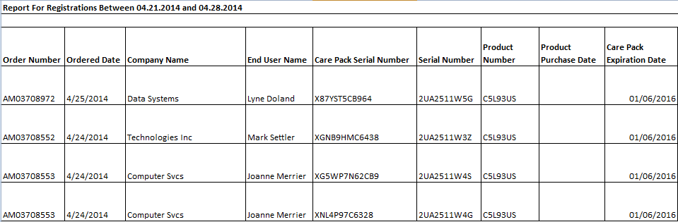
Registration Report in Excel Format (continued)
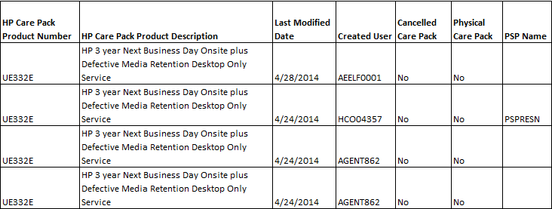

8.2 Get Orders Detail Report in Excel Format

Step 3 Choose the Get Orders Detail Report in Excel format option.
Partner Inquiries Screen – Orders Detail Report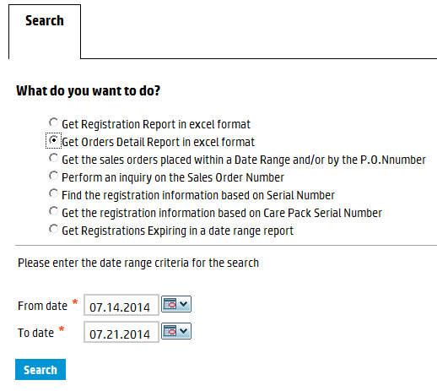
Step 4 Enter or select a start date (From date) and an end date (To date) for the query.
Step 5 Click the “search” button.
At this point, the Orders Detail Report opens in a separate Excel spreadsheet.
Note
You can open or save the spreadsheet.

Orders Detail in Excel Format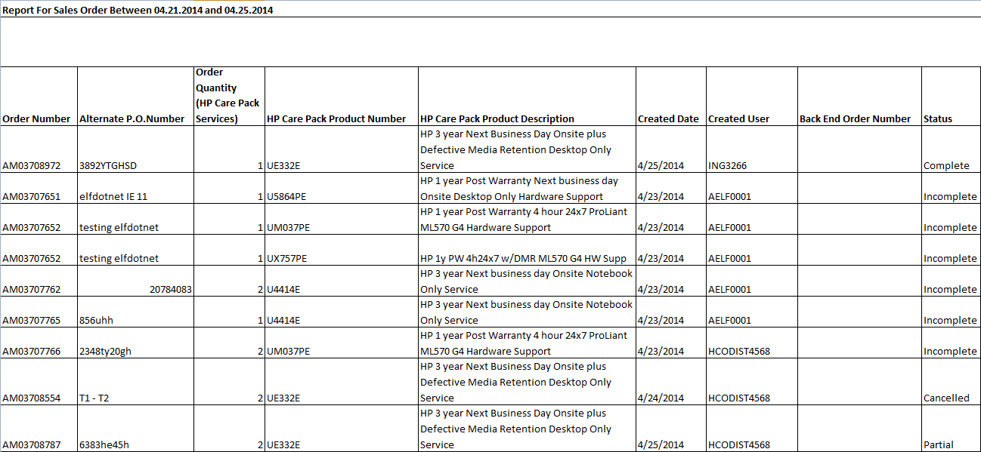

Note
The status column refers to the registration status of the order, not the order itself.

8.3 Get the Sales Orders Placed Within a Date Range and/or by the P.O. Number

Step 3 Choose the Get the Sales Orders Placed within a Date Range and/or by the P.O. Number option.
Partner Inquiries Screen – Sales Orders by Date Range and/or P.O. Number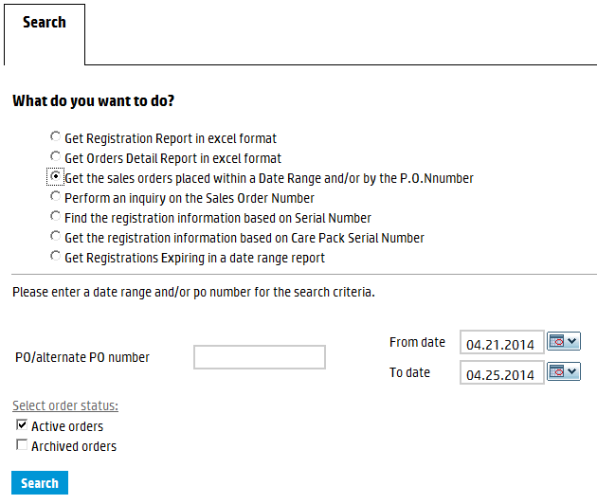
Step 4 Enter the P.O. number or a start date (From date) and an end date (To date) for the query.
Note
The P.O. number can be a Tier 1 P.O. number, a customer P.O. number or a Tier 2 reseller alternate P.O. number.

Step 5 Select Active orders, Archived orders, or both.
Note
Once you archive an order, the order is hidden from you for administrative ease, but you can always unarchive or search for archived orders, if necessary.

Step 6 Click the “search” button.
At this point, a list of sales orders appears.
List of Sales Orders by PO and/or Date Range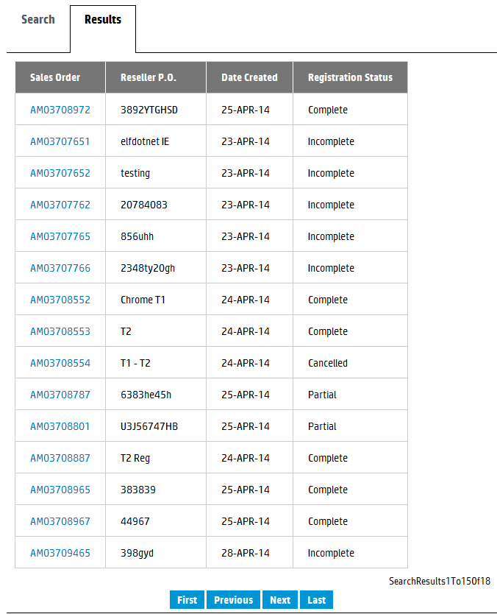
To sort by heading, click any hyper-linked heading.
To view the sales order, click any hyper-linked sales order number.
Note
To sort the list by heading click the hyper-linked heading itself.

Step 7 Click the hyper-linked sales order number to view the details of the order.
At this point, the sales order appears

Note
The sales order number is the reference number provided at the end of an on-line order. (Example: EME0000123).

Sales Order Detail Screen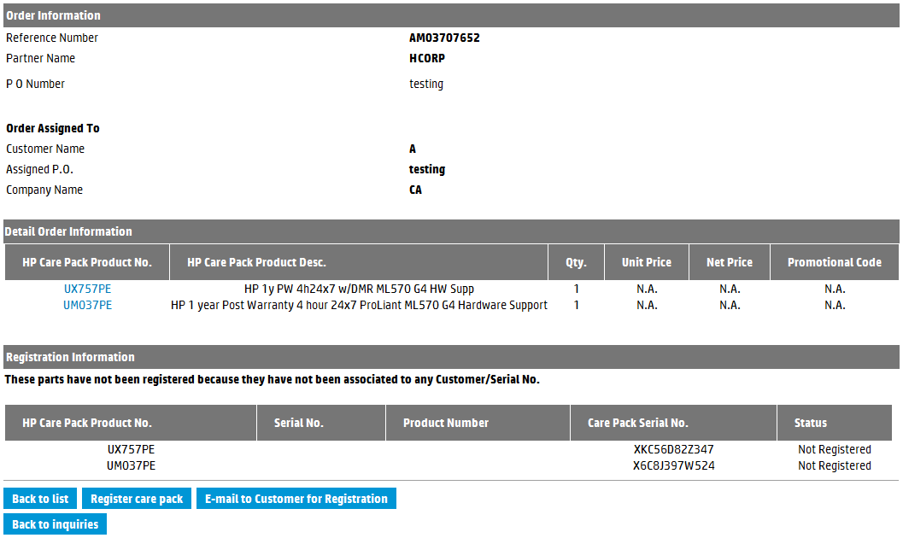
Step 8 Use the function buttons at the bottom of the page to execute the preferred next step.

8.4 Perform an Inquiry on the Sales Order Number

Step 3 Choose the Perform an Inquiry on the Sales Order Number option.
Partner Inquiries Screen – Sales Order Number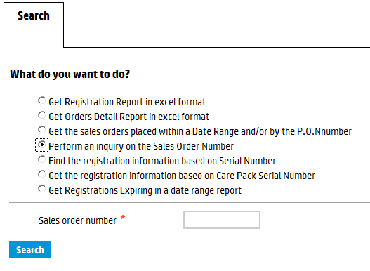

Step 4 Enter the Sales order number.
Note
The sales order number is the reference number provided at the end of an on-line order. (Example: EME0000123).

Step 5 Click the “search” button.
At this point, the Order Information and Registration Information sections appear.
Sales Order Detail Screen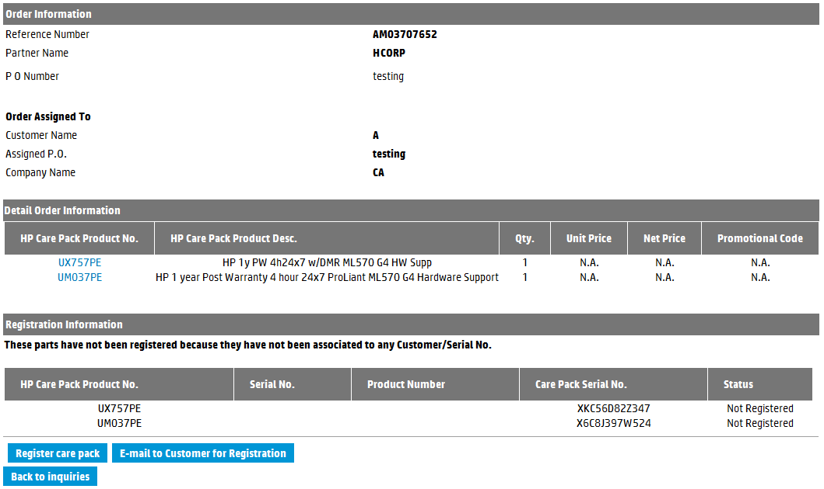
Step 6 Use the function buttons at the bottom of the page to execute the preferred next step.

8.5 Find the Registration Information Based on Serial Number

Step 3 Choose the Find the registration information based on Serial Number option.
Partner Inquiries Screen – Serial Number
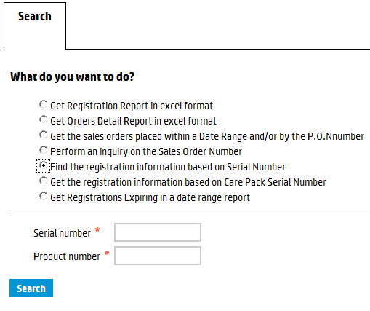
Step 4 Enter the serial number and product number.
Note
You must enter a product number, along with the serial number.

Step 5 Click the “search” button.
At this point, a list of fixed support services registered to this serial number appears.
Registrations for this Serial Number
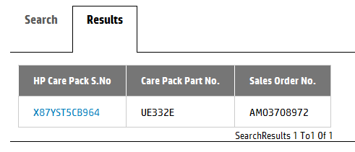

Step 6 Click the hyper-linked Fixed Support Services Serial Number.
At this point, the Registration Information appears.
Registration Information Screen
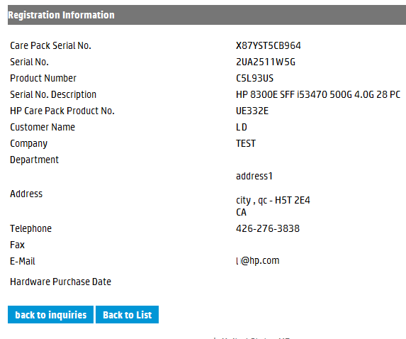

8.6 Get the Registration Information Based on Fixed Support Services Serial Number

Step 3 Choose the Get the registration information based on Care Pack Serial Number option.
Partner Inquiries Screen – Care Pack Serial Number
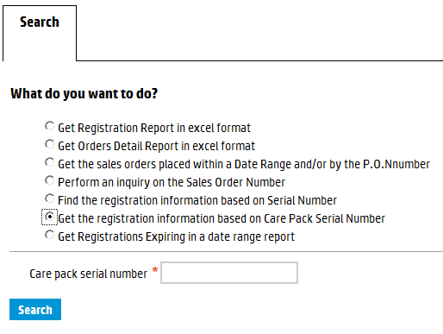
Step 4 Enter the Fixed Support Services Serial Number in the “Care pack serial number” field.
Step 5 Click the “search” button.
At this point, the Registration Information for the fixed support services appears.

Registration Information Screen
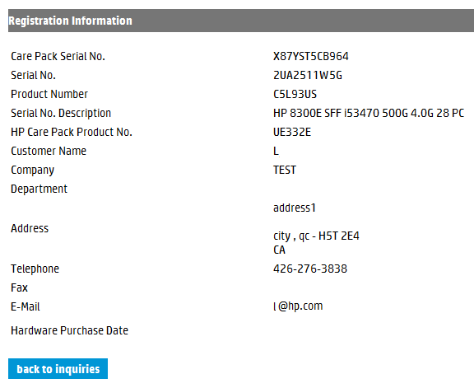

8.7 Get Registrations Expiring in a date range

Step 3 Choose the Find registrations expiring within the Next 90 days option.
Partner Inquiries Screen – Expiring in Next 90 Days
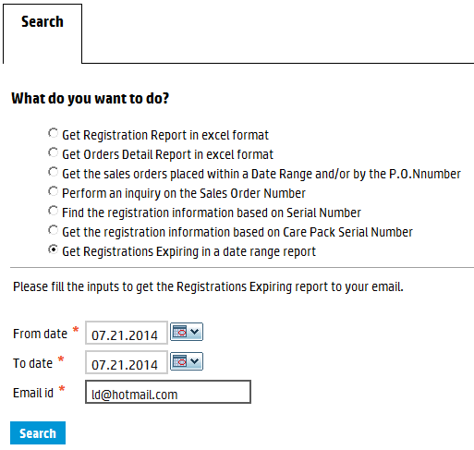

Notes
The “From” and “To” dates are defaulted to a 90 days period that starts with today’s date. The Email Id is defaulted to the email address associated with the account used for logging in the tool.

The period cannot be more than 90 days, but can be any period in the future or past.

The report will be sent to the email id indicated.

Step 4 Change or select different dates as required as well as update the email id if necessary.
Step 5 Click the “search” button.
At this point, a message appears at the top of the screen to indicate the report will be sent via email.
Step 6 Once the email is received click to open the attachment containing the zipped report.

